**Case Study:** Unified Customer Data Platform Using Microsoft Fabric for Banking

**Client:** Commercial Bank

**Project:** Unified Single Customer View (SCV)

**Role:** Microsoft Certified Fabric Analytics Engineer Associate

**Tools & Services Used:** Microsoft Fabric (Data Factory, Dataflows Gen2, Lakehouse, Real-Time Analytics, Power BI)**,** Azure Data Lake Storage (ADLS), Salesforce, SAP, Firebase, Finacle (External Data Sources)

**Overview**

The bank needed to consolidate customer data scattered across multiple systems—CRM (Salesforce), ERP (SAP), mobile engagement (Firebase), and core banking (Finacle)—into a single customer view (SCV). The goal was to improve data-driven decision-making across departments, streamline marketing efforts, and enable real-time insights, all while simplifying the data management layer.

**Challenges**

* Disconnected systems with various integration patterns (REST, Event-Driven, SOAP), Inconsistent formats, null values, duplicates, and varying schemas
* Multiple stakeholders across marketing, operations, and compliance needed different views of the data
* High cost and complexity in managing multiple analytics tools and data pipelines
* Difficulty scaling to support real-time insights and reporting

**Solution with Microsoft Fabric**

1. Data Ingestion & Storage

Used Data Factory (within Fabric) to connect to Salesforce, SAP, Firebase, and Finacle (via APIs).

Raw data was ingested into OneLake (Microsoft Fabric's unified storage layer) using Dataflows Gen2, enabling schema mapping and initial data landing.

2. Data Transformation

* Cleaned and standardized the data using Data Engineering pipelines in Fabric:
* Removed nulls
* Standardized date formats
* Removed duplicates
* Harmonized schemas
* Created a Lakehouse model that brought together clean data from all sources.

3.Integration & Modeling

Joined and integrated data into a unified Single Customer View (SCV) within the Lakehouse.

Business-friendly semantic models were created using Power BI DirectLake, allowing near real-time insights without needing to copy data**.**

**4**. Real-Time Analytics & Visualization

Used Real-Time Analytics in Microsoft Fabric (powered by KQL) to stream and analyze live events such as customer interactions, transactions, and support cases.

Delivered dashboards to business teams using Power BI, embedded with narrative-driven visuals and simplified views for non-technical users.

**Results**

* Delivered a 360° customer view, enabling personalized marketing and proactive service delivery
* Reduced time-to-insight by over 60% through a unified Fabric environment
* Increased adoption of analytics by non-technical users thanks to simplified Power BI dashboards
* Achieved real-time visibility into customer behavior, improving operational responsiveness
* Centralized governance, monitoring, and cost control via Microsoft Fabric’s integrated workspace

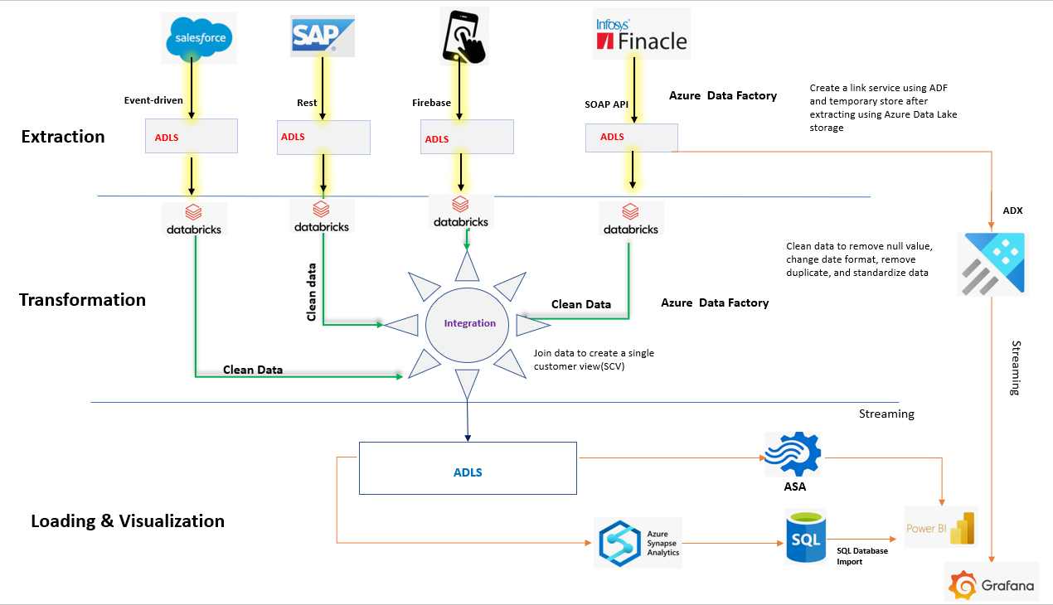

**Project: Customer Data Integration and Analytics Pipeline**

**Objective:**

To extract, transform, and visualize customer data from multiple sources (Salesforce, SAP, Firebase, and Finacle) to create a Single Customer View (SCV) and enable real-time analytics and reporting using Azure services.

**Resources Used**

|  |  |  |
| --- | --- | --- |
| Component | Purpose | Azure service |
| Data Extraction | Extracting customer data from multiple sources | ADF, APIs (REST, SOAP, Firebase, Salesforce) |
| Data Storage | Staging raw data | Azure Data Lake Storage (ADLS) |
| Data Transformation | Cleaning, standardizing, and integrating data | Azure Databricks |
| Batch Analytics | Historical analysis and querying | Azure Synapse Analytics, SQL Database |
| Real-Time Analytics | Streaming and real-time monitoring | Azure Data Explorer (ADX), Azure Stream Analytics (ASA) |
| Visualization | Dashboard and Report | Power BI, Grafana |

**Business Impact and Value Delivered**

**Unified Customer Insights:** Created a single source of truth by enabling a Single Customer View (SCV) through data integration from multiple sources.

**Real-Time Analytics:** Business users can monitor customer interactions and transactions live using ADX and ASA.

**Improved Data Quality:** Standardized and cleaned data ensures accuracy in decision-making.

**Scalability and Automation:** Azure services automate data workflows, reducing the manual effort and possible errors.

**Architecture Breakdown and Workflow**

**Step 1.** **Extraction Phase:** Data was Ingested from Multiple Sources to ADLS

The Data was extracted from four essential sources:

* Salesforce (Event-driven API)
* SAP (REST API)
* Mobile App (Firebase) (Realtime API)
* Finacle (Core Banking System) (SOAP API)

Azure Data Factory (ADF) orchestrates data movement from the four sources into Azure Data Lake Storage (ADLS) for integration and transformation. In comparison, the ADLS here acted as the temporary staging layer to hold raw data before transformation began.

**Step 2.** **Transformation Phase:** The Data was cleaned and Standardized using Azure Databricks by running the following activities:

* Removing any null values
* Standardizing formats of dates
* Removing duplicated values
* Structuring data
* optimizing data

**Step 3. Integration Phase:** The data from different sources was transformed independently and integrated to create a Single Customer View (SCV), Azure Data Factory (ADF) enables the integration from silo of siloed cleaned data from all sources into a unified format. The SCV dataset is then stored back into ADLS. Here, the data became ready for both batch analytics and real-time streaming.

**Step 4. Visualization Phase:** Here, Analytics and Reporting were performed in two phases

**Phase 1: Batch processing**

The Batch Processing involved using Azure Synapse Analytics to load the transformed data from ADLS for advanced analytics, reporting, and querying. At this stage, the data was also imported into the SQL Database for structured storage and additional Business Intelligence analytics and insight visualization using Power BI

**Phase 2: Real-Time Data Streaming**

Data streaming was performed from ADLS holding the SCV unified data. The data was sent to Azure Data Explorer (ADX), and Azure Stream Analytics (ASA) was used for real-time monitoring, anomaly detection, and the visualization was done with Grafana and Power BI

Users can make informed decisions by utilizing insight from customer behavior, transactions, and business performance generated by interactive and real-time dashboards.